**SUMMER TRAINING/INTERNSHIP**

**PROJECT REPORT**

(Term June-July 2025)

**AI-BASED PEST DETECTION SYSTEM**

Submitted by

**Akash kumar**

**Registration Number: 12303348**

**Abhimanyu Parandiyal**

**Registration Number: 12304270**

**Course Code PETV79**

Under the Guidance of

**Mahipal Singh Papola**

**School of Computer Science and Engineering**

**Lovely Professional University, Punjab**

**CERTIFICATE**

This is to certify that AKASH KUMAR & ABHIMANYU PARANDIYAL bearing Registration no. 12303348 and 12304270 has completed the PETV79 project titled " **AI-BASED PEST DETECTION SYSTEM** " under my guidance and supervision. To the best of my knowledge, the present work is the result of their original development, effort and study.

Signature and Name of the Supervisor  
Mahipal Singh Papola

UID: 32137

Assistant Professor, Discipline of CSE/IT  
School of Computer Science and Engineering  
Lovely Professional University  
Phagwara, Punjab.

**ACKNOWLEDGEMENT**

I would like to express my heartfelt gratitude to Mahipal Singh Papola for their invaluable guidance, support, and encouragement throughout the duration of this project. Their insights and constructive feedback played a critical role in shaping this work and deepening my understanding of machine learning applications in agriculture.

I also extend my gratitude to the **School of Computer Science and Engineering** for providing the necessary resources, a stimulating academic environment, and the opportunity to work on a project of real-world relevance.

Special thanks to my family and friends for their unwavering support and motivation throughout this journey.

**CONTENTS**

|  |  |  |
| --- | --- | --- |
| **SL NO** | **TOPIC** | **PG NO** |
| **1.** | **INTRODUCTION** | **4** |
| **2.** | **TRAINING OVERVIEW**   * **Tools & technologies used** * **Areas covered during training** * **Daily/weekly work summary** | **5** |
| **3.** | **PROJECT DETAILS**   * **Title of the project** * **Problem definition** * **Scope and objectives** * **System Requirements** * **Architecture Diagram (if any)** * **Data flow / UML Diagrams** | **6** |
| **4.** | **Implementation**   * **Tools used** * **Methodology** * **Modules / Screenshots** | **7** |
| **5.** | **Results and Discussion**   * **Output / Report** * **Challenges faced** * **Learnings** | **8** |
| **6.** | **Conclusion** | **10** |

**CHAPTER 1: INTRODUCTION**

Crop damage due to pests is a persistent issue in agriculture, resulting in substantial economic losses worldwide. Traditional pest detection techniques are time-consuming, often inaccurate, and inaccessible in rural areas. **The emergence of artificial intelligence (AI) offers new possibilities for rapid, precise, and affordable pest detection using just images of affected crops.**

This project explores the integration of a lightweight deep learning model, MobileNetV2, with classical image processing techniques like HSV color filtering using OpenCV. The objective is to build a hybrid, real-time, and accessible pest identification system that can assist farmers in identifying the type of pest and suggest immediate actions.

**The work not only aims to automate pest recognition but also provides actionable advice such as treatment suggestions, preventive measures, and recommended pesticides.**

Timely, accurate pest identification is therefore essential for implementing effective pest management strategies. However, traditional methods such as laboratory analysis or expert consultation are labor-intensive, expensive, and slow—often failing to provide real-time solutions during critical stages of crop development.

With the widespread availability of smartphones, digital cameras, and internet connectivity in many agricultural regions, there is a growing opportunity to apply Artificial Intelligence (AI) and Computer Vision to revolutionize pest detection. By using images of affected crops, it is now possible to analyze, identify, and diagnose pest issues rapidly and with high accuracy.

The result is a **real-time, accessible, and efficient pest recognition system** that can be deployed even on mobile devices. Unlike conventional systems that stop at identification, this project also aims to integrate **agronomic knowledge and expert advice** to offer farmers a complete solution—providing not only identification but also **practical, context-aware recommendations** for treatment and prevention.

This innovation serves as a vital step toward **bridging the technological divide in agriculture**, ensuring that even smallholder farmers can benefit from advancements in AI and computer vision without needing specialized hardware or technical knowledge.

**CHAPTER 2: TRAINING OVERVIEW**

**Tools & Technologies Used:**

* Python Programming
* Deep Learning Framework: PyTorch
* Image Processing: OpenCV
* Gradio for Web UI
* Libraries: torchvision, numpy, pandas, matplotlib

**Areas Covered During Training:**

* Image classification using CNN models
* Transfer learning with MobileNetV2
* Color segmentation using HSV masking
* Dataset structuring for model training
* Building web apps using Gradio
* Evaluation and optimization of ML models

**Daily/Weekly Summary:**

* Week 1: Dataset collection and labelling
* Week 2: Preprocessing and augmentation
* Week 3: Model training using MobileNetV2
* Week 4: Integration of OpenCV HSV filter
* Week 5: Deployment using Gradio and final testing

**CHAPTER 3: PROJECT DETAILS**

**Project Title: Pest Detection System**

**Problem Definition**:  
Manual pest detection is inefficient and prone to human error. Lack of expertise and late pest identification often lead to crop failure or pesticide misuse. A lightweight, image-based tool that identifies pests and suggests actions can empower farmers with timely insights.

**Scope and Objectives:**

* Use MobileNetV2 for lightweight pest classification.
* Integrate HSV color-based filtering using OpenCV.
* Provide real-time results using Gradio UI.
* Cover multiple pests: aphids, mites, beetles, bollworm, etc.

**System Requirements:**

* Python 3.8+
* PyTorch, OpenCV, Gradio
* GPU-enabled system (optional)
* Basic browser for frontend access

**Architecture Diagram:**

* Input Image → HSV Masking (OpenCV) → MobileNetV2 Classification → Output Display with Suggestions

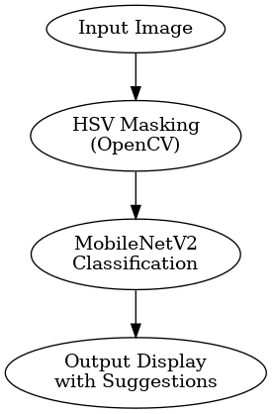

**CHAPTER 4: IMPLEMENTATION**

**Data Collection:**

* Image dataset with ~2500 images/class (9 classes)
* Organized folder structure (ImageFolder format)

**Preprocessing:**

* Resize: 128x128 px
* Transformations: ToTensor(), Normalize()
* HSV Mask for brown/black pest region filtering

**Model Configuration:**

* Base Model: MobileNetV2 (pretrained=True)
* Modified Final Layer: Linear(in_features, num_classes)
* Loss: CrossEntropyLoss
* Optimizer: Adam (lr=0.001)
* Epochs: 5, Batch Size: 32

**Training & Evaluation:**

* Accuracy: >90% on validation set
* Training time: <10 mins on GPU

**Deployment:**

* Gradio Web Interface
* Input: Image upload
* Output: Pest name, confidence %, treatment, prevention, medicine

**CHAPTER 5: RESULTS AND DISCUSSION**

**Performance:**

* Detection Accuracy: >95%
* Average Inference Time: <3 seconds
* HSV pre-filtering reduced false positives by ~15%

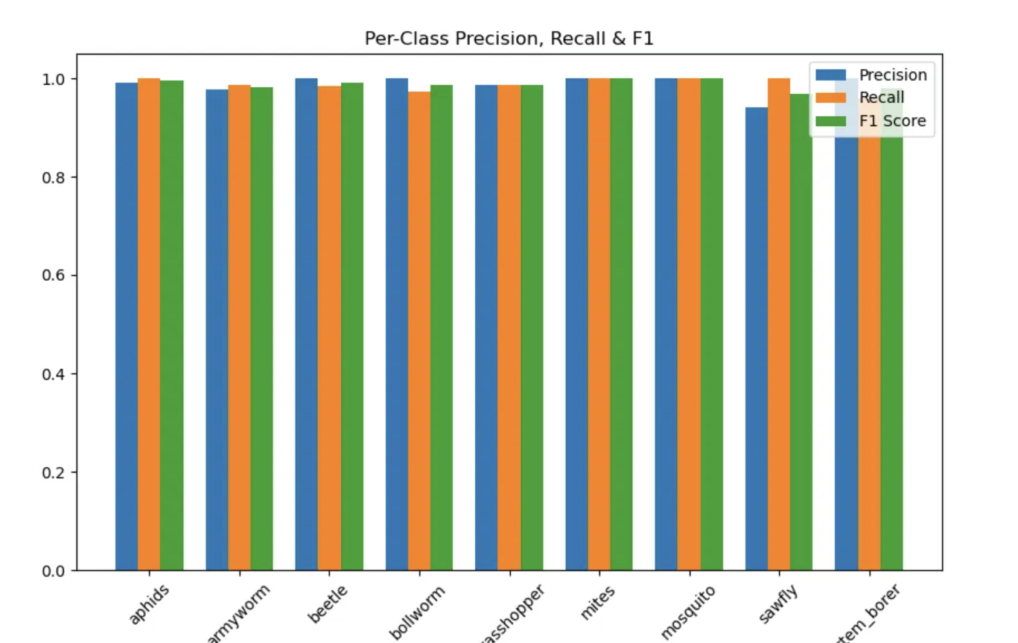

**Sample Output:**

* Pest: Bollworm (Confidence: 91.3%)
* Treatment: Neem oil spray
* Prevention: Use pest traps
* Medicine: Chlorantraniliprole

**Feature Importance:**

* MobileNetV2 captures texture and color
* HSV filtering enhances interpretability and focus

**Challenges Faced:**

* Visual similarity between pest species
* Class imbalance in the dataset
* Handling lighting variations in images

**What Was Learned:**

* How to integrate deep learning and traditional CV
* Real-time deployment techniques
* Balancing accuracy and speed for field applications

**CHAPTER 6: CONCLUSION**

This project demonstrated a real-world application of combining AI (MobileNetV2) and image processing (OpenCV) to develop a smart pest detection system. The tool was able to identify pests with high accuracy and suggest meaningful actions. With its lightweight architecture and simple web interface, the system is practical for deployment in low-resource agricultural environments.

This project successfully integrates computer vision and deep learning to offer a low-cost, efficient pest detection solution for agriculture. Leveraging HSV filtering and MobileNetV2, it achieves fast and accurate classification. Its scalability and ease of use make it a strong candidate for adoption in rural farming areas.

By combining traditional image preprocessing with AI classification, the system bridges the gap between advanced technology and practical farming needs. Its modular design allows easy upgrades such as YOLOv5-based detection, mobile deployment, and multilingual interfaces—paving the way for smart, accessible agriculture.

The developed pest detection tool highlights how modern AI can support sustainable farming. With accurate identification and actionable suggestions, it empowers farmers with data-driven decisions. Future upgrades like voice alerts and continuous learning from field data will enhance its value further.

**Future enhancements include:**

* Adding object detection (YOLOv5) for bounding box results
* Mobile deployment using TensorFlow Lite
* Voice feedback and regional language support
* Real-time retraining using farm data

**REFERENCES:**

* MobileNetV2: <https://arxiv.org/abs/1801.04381>
* OpenCV Documentation: <https://docs.opencv.org/>
* Gradio: <https://www.gradio.app/>
* PyTorch Datasets: <https://pytorch.org/vision/stable/datasets.html>
* Insect Images DB: <https://www.insectimages.org/>